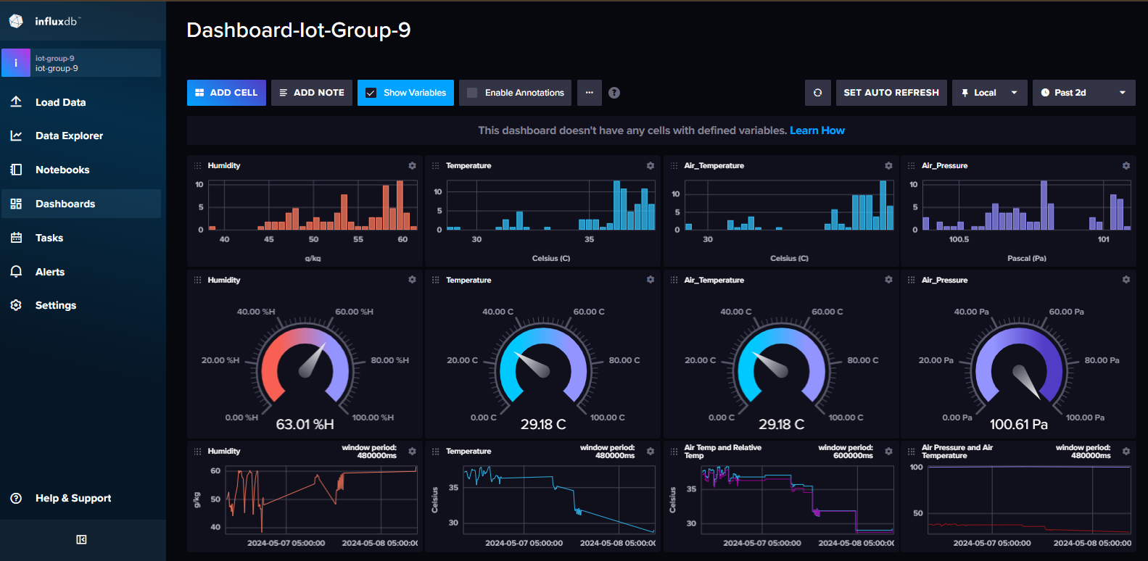
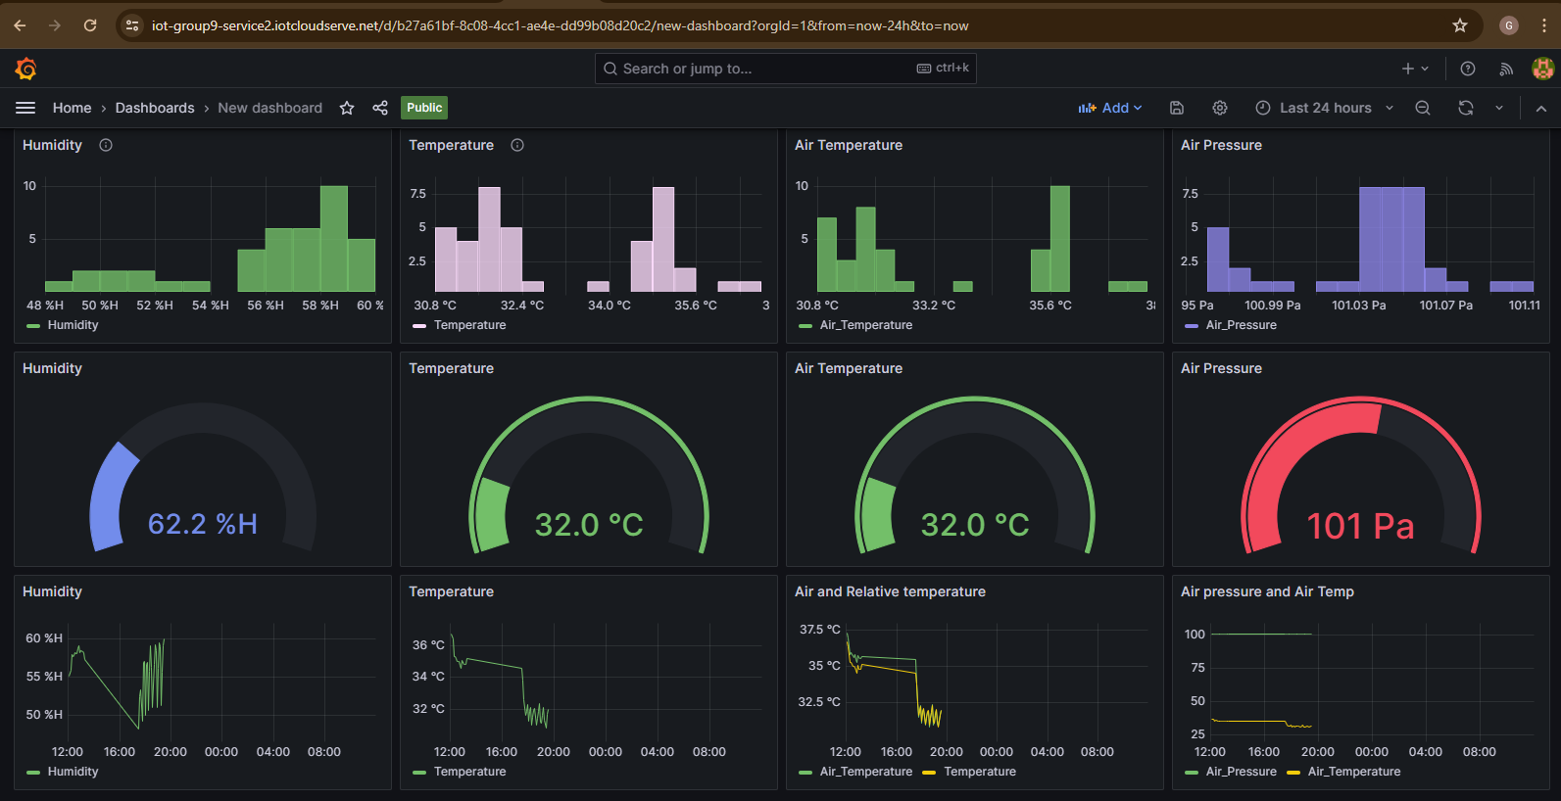

Link for public to access the data on our dashboard
https://iot-group9-service1.iotcloudserve.net/public-dashboards/f04ab8d463984deda1a90e9c6214295c

